Rover Lidar System

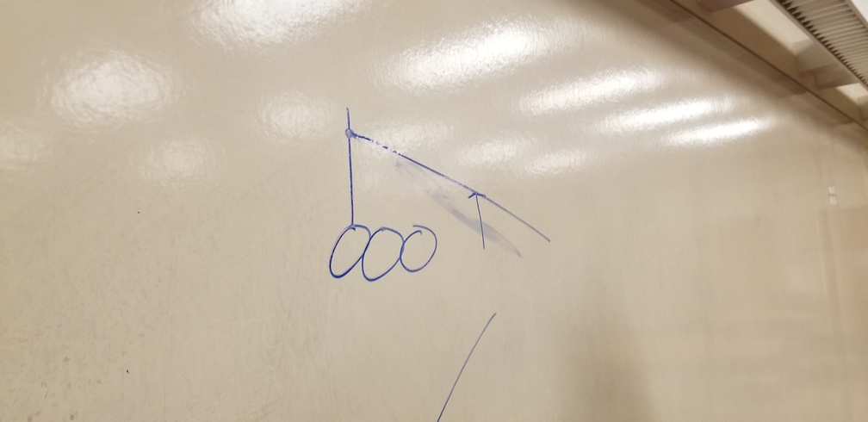

The system works by mounting a LIDAR system on the mast of the rover and angling it down in order to see how tall an obstacle is in front of it. It calculates this by calculating the hight of the